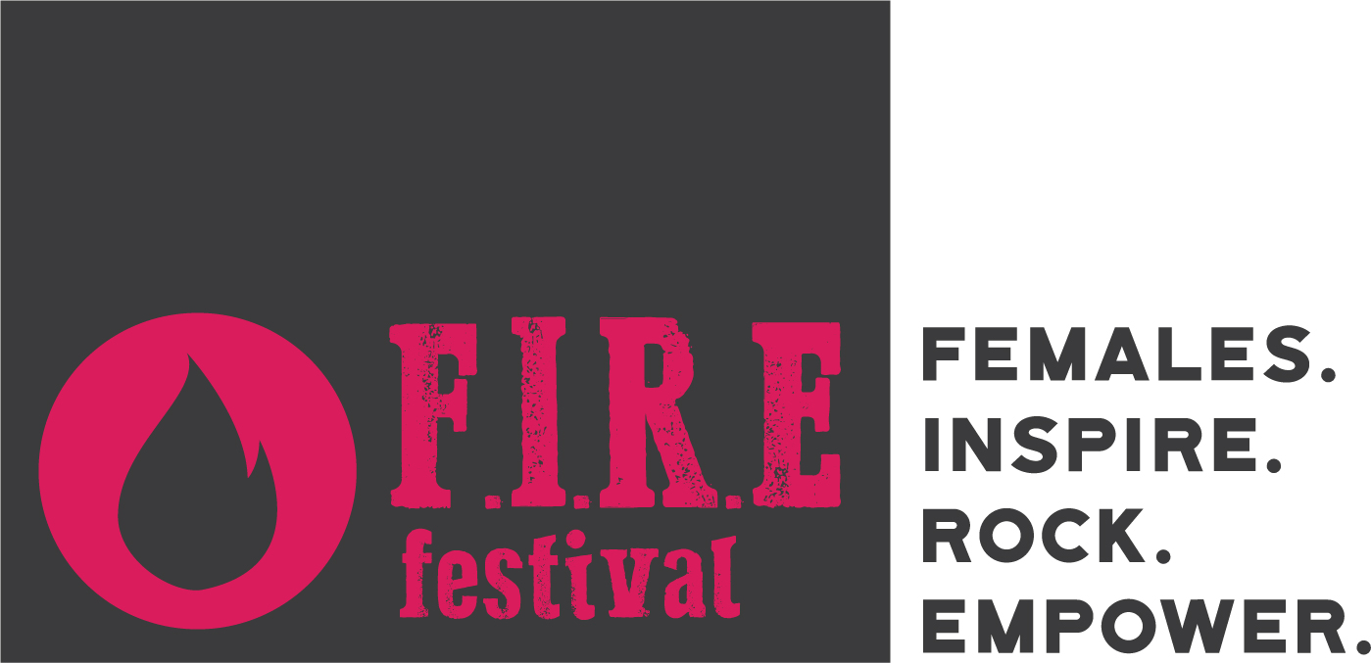

SPONSOR SUBMISSION
Email back to Jess at jessrocknroad@gmail.com

- Name:
- Business name:
- Email:
- Phone number:
- Website:
- Professional Facebook:
- Instagram:
- Twitter:
- Bio (max 300 words):
- Sponsors can support this festival in several ways:
  - Artist sponsorship: cash donations of $50+
  - Goods sponsorship: donate items to the raffle
  - Volunteer: assist day-of running the festival
  - Media sponsorship: run ads promoting the festival through your publication or news network
  - Venue sponsorship: Host the festival or micro festivals we use to build up to bigger events
  - Please specify which sponsorship you’d be interested in and/or the amount to be given:
- We promote our sponsors thoroughly. Please send a high-res vector logo (no background) to do this.

THANK YOU!

