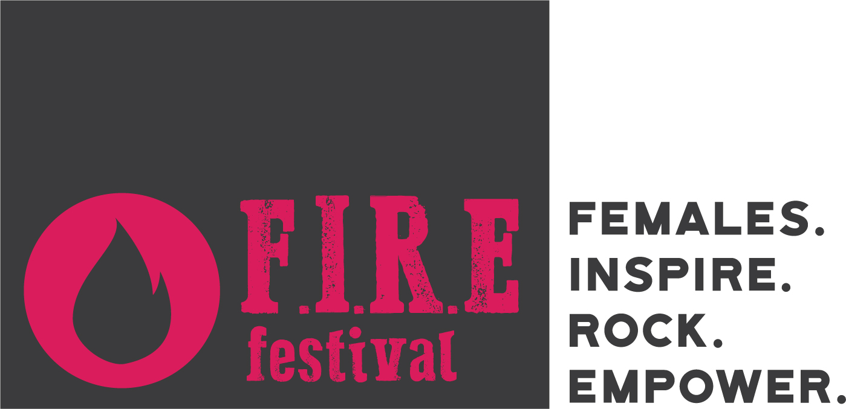

ARTIST SUBMISSION
Email back to Jess at jessrocknroad@gmail.com

- Artist name:
- Email:
- Phone number:
- Genre:
- Do you play an instrument?
  - More than one? Specify:
- Do you write original music?
- What formation would you bring to the festival (Solo? Duo? Band? Would all members be female?):
  - What would your technical requirements include?
- Website:
- Professional (not personal) Facebook:
- Instagram:
- Twitter:
- Bio (max 300 words):
- Link to music:
- Describe what your set would be like at the FIRE festival (ex. Solo acoustic / live looping / a mix of originals and covers, etc.):
- You’ll be required to submit at least three high-resolution professional photos for promotion. Do you have these?
- You are encouraged to sell merchandise at the festival. Do you have any?

THANK YOU!

